**ZENER DIODES**

**LAB # 07**



**Spring 2023**

**CSE-206L Electronic Circuits Lab**

Submitted by: **Ali Asghar**

Registration No.: **21PWCSE2059**

Class Section: **C**

“On my honor, as student of University of Engineering and Technology, I have neither given nor received unauthorized assistance on this academic work.”

Submitted to:

**Engr. Abdullah Hamid**

**Date**: 7th July 2023

**Department of Computer Systems Engineering**

**University of Engineering and Technology, Peshawar**

**OBJECTIVES:**

* To study the characteristics of Zener diode.
* To study the voltage regulation in Zener diode regulation circuit.

**EQUIPMENT:**

* Oscilloscope
* Function Generator
* Digital Multimeter (DMM)

**COMPONENTS**

* Zener Diode
* Resistors: 1kΩ
* Potentiometer
* Variable Voltage Source

**THEORY:**

**DIODE:**

A diode is a two-terminal electronic component that conducts current primarily in one direction. it has low resistance in one direction, and high resistance in the other.

**ZENER DIODE:**

The Zener diode is a specialized P-N junction diode designed to function in the reverse biased mode. While forward biased, it behaves like a regular diode. However, it possesses a specific voltage called the breakdown voltage, at which it experiences breakdown in the reverse biased state. Unlike regular diodes that get damaged at the breakdown voltage, the Zener diode is specifically engineered to operate in the reverse breakdown region.

The fundamental principle behind the Zener diode is known as Zener breakdown. When a diode is heavily doped, its depletion region becomes narrow. When a high reverse voltage is applied across the junction, a strong electric field is created at the junction, leading to the generation of electron-hole pairs. As a result, a substantial current flows, which is referred to as Zener breakdown.

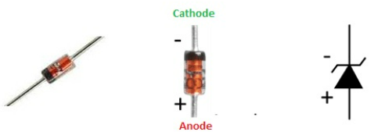

Figure 1, Zener Diode Diagram and Symbol

**PROCEDURE:**

**Part A: Zener Diode Characteristics:**

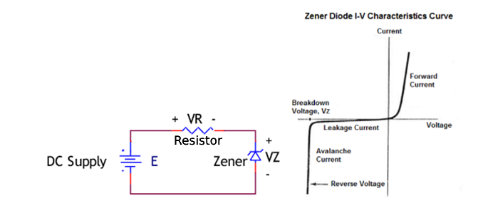

Figure 2, Zener Diode Series Circuit

* Construct the circuit of Fig. 2. Set the DC supply to 0 V and record the measured value of R.
* Set the DC supply (E) to the values appearing in Table 1, 2 and 3 and measure both VZ and VR. Calculate the Zener current, IZ using the Ohm’s law given in the table and complete the table.

**Part B: As A Voltage Regulator:**

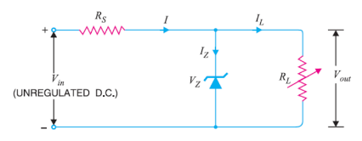

Figure 3, Voltage Regulator Circuit

* Construct the circuit of Fig. 3. Record the measured value of each resistor
* Measure the value of VL(Vout) and VR.
* Using the measured values, calculate the value for current across R i.e I, current across RL i.e IL, and current across the Zener Diode i.e Iz and complete the table 4.

**RESULTS:**

**PRACTICAL:**

**Forward Bias (Resistance=1 KΩ):**

|  |  |  |
| --- | --- | --- |
| Source Voltage | Voltage Across Diode (Vz) | Current Across Diode (Iz) |
| 5 Volts | 0.42Volts | 0.42 mA |

Table 1.1

**Reverse Bias (Resistance=1 MΩ):**

|  |  |  |
| --- | --- | --- |
| Source Voltage | Voltage Across Diode (Vz) | Current Across Diode (Iz) |
| 5 Volts | 5.3 Volts | 0 A |
| 15 Volts | 15.18Volts | 15.03 µA |

Table 1.2

**PROTEUS:**

**Reverse Bias:**

Figure 4, Proteus Circuit for Zener Diode Reverse Biased

**Calculations:**

|  |  |  |
| --- | --- | --- |
| Source Voltage | Voltage Across Diode (Vz) | Current Across Diode (Iz) |
| 5 Volts | 5 Volts | 0 A |
| 10 Volts | 9.91 Volts | 0.08 mA |
| 15 Volts | 10 Volts | 4.97 mA |
| 20 Volts | 10 Volts | 9.95 mA |
| 50 Volts | 10.1 Volts | 14.9mA |

Table 2

**Forward Bias:**

Figure 5, Proteus Circuit for Zener Diode Forward Biased

**Calculations:**

|  |  |  |
| --- | --- | --- |
| Source Voltage | Voltage Across Diode (VD) | Current Across Diode (ID) |
| 5 Volts | 0.73 Volts | 4.27 mA |
| 10 Volts | 0.75 Volts | 9.25 mA |
| 15 Volts | 0.76 Volts | 14.2 mA |
| 20 Volts | 0.77 Volts | 19.2 mA |
| 50 Volts | 0.80 Volts | 49.2 mA |

Table 3

**As Voltage Regulator:**

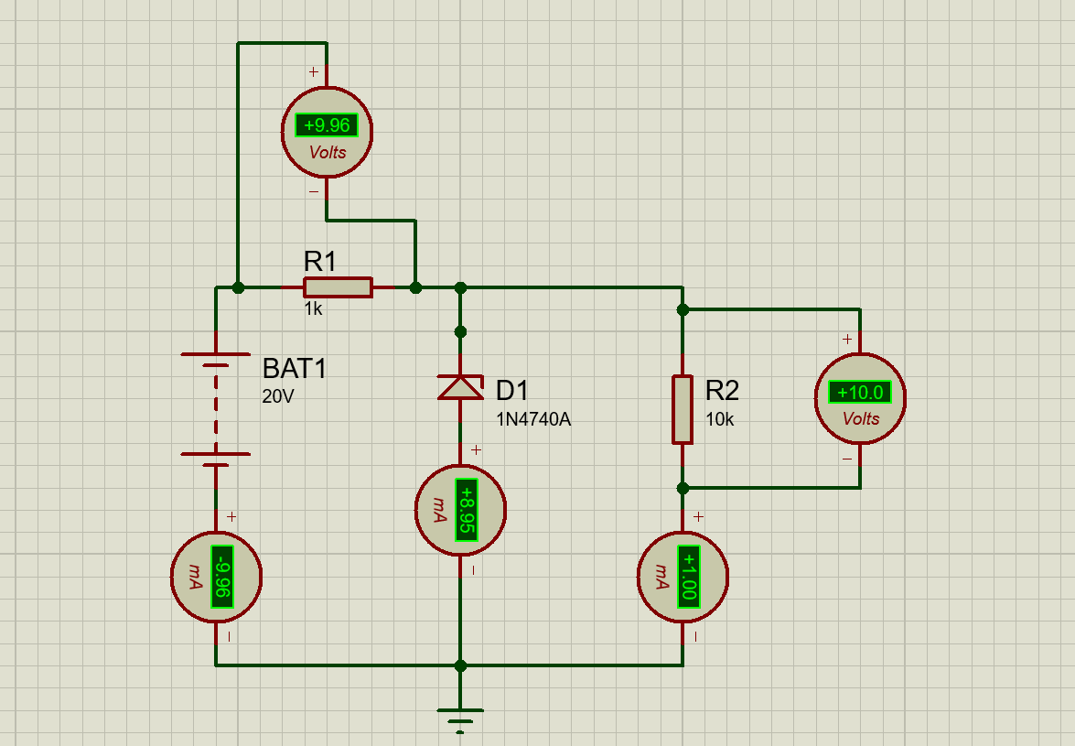

Figure 6, Voltage Regulator Circuit in Proteus

**Calculations:**

For R=1kΩ, RL = 10kΩ,

|  |  |  |  |  |  |
| --- | --- | --- | --- | --- | --- |
| Vin | VR | VL | Iz | IL | I |
| 5 Volts | 0.45V | 4.55V | 0mA | 0.45mA | 0.45mA |
| 10 Volts | 0.91V | 9.09V | 0mA | 0mA | 0mA |
| 20 Volts | 9.96V | 10V | 8.95mA | 1mA | 9.95mA |
| 30 Volts | 19.9V | 10.1V | 18.9mA | 1.01mA | 19.9mA |
| 50 Volts | 39.9V | 10.1V | 38.9mA | 1.01mA | 39.9mA |

Table 4

**Conclusion:**

We successfully performed experiments with Zener diode and learned about its properties. We also learned about its uses as voltage regulation.